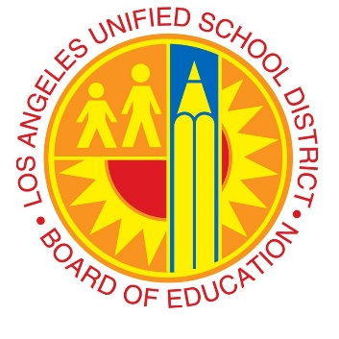
Woodland Hills Academy Middle School

Los Angeles Unified School District, Local District Northwest
20800 Burbank Blvd. Woodland Hills, CA 91367
Visit our website: woodlandhillsacademy.org

We are recruiting collaborative, innovative, passionate educators
to start immediately.

Our Mission/Vision: Woodland Hills Academy is a safe, supportive and innovative learning community where students are inspired and valued as they master 21st Century skills. Our mission is to develop creative minds and critical thinkers who will pursue lifelong learning, ethical responsibility, and thoughtful global citizenship. We strive to engage students in activities which will challenge them intellectually, socially, emotionally, physically, and build skills necessary to compete in our ever changing world. Our student scholars will learn to exhibit compassion and empathy for others while acting thoughtfully and ethically both in school and beyond.

Seeking Candidates for the 2019-2020 School Year:
Posted on LAUSD Job Board: http://achieve.lausd.net/Page/1566
Classroom
Science and Health

Required:
California Single Subject and CLAD Credentials
Additional Supplemental Single Subject Credentials Encouraged

Interested candidates must submit electronically:
Letter of Intent describing why you are an ideal candidate, a resume and 3 Current References (Phone Number and emails) to:

Alma Salazar, Principal
20800 Burbank Blvd
Woodland Hills, CA. 91367
Telephone (818) 226-2900
Fax (818) 716-0649
Email to: alma.c.salazar@lausd.net

The Los Angeles Unified School District intends that all qualified persons shall have equal opportunities for employment and promotions.

